CBOE
Oracle Elimination – Phase I

Requirement Specification Document
Version 1.0



Last Modified Date: 16th April 2009


The information contained in this document is confidential and intended for the named recipient only. This information is property of “CBOE” and copying or disclosure by any other person is strictly prohibited. If you have received this documentation in error, please notify sender immediately.
Table of Contents
1 Introduction 6
1.1 Purpose & Scope of this document 6
1.2 Intended Audience 6
1.3 Document Structure 7
2 System Overview 7
2.1 Current System Overview 7
2.2 Future System Overview 8
2.3 Future State 9
3 Requirement Analysis – Oracle Elimination Phase I 10
3.1 High-level functionalities to be implemented 10
3.2 Feasibility studies of various functionalities 10
3.2.1 Configure New Process: MD History Server 10
3.2.2 MD History Server – Internal Design 11
3.2.3 Data Flow and Load Distribution (Different Options) 14
3.2.4 CDB Failure Handling 15
3.2.5 Handling of MDH Queries 17
3.2.6 MDH Server Failure Handling 18
3.2.6.1 Detect Failure 18
3.2.6.2 Switching to the back up process 20
3.2.6.3 Both Master and Slave MDH server down 20
3.2.7 Network Failure Handling 20
3.2.7.1 Network failure between CDB and MDH Master Server 20
3.2.7.2 Network failure between MDH Master Server and MDH Slave Server 21
3.2.7.3 No Activity Detection / Network failure between Event Channel and MDH servers 23
3.2.8 Data Gap Detection and Handling 24
3.2.9 Use Case 25
3.2.9.1 MDH Server process 25
3.2.9.2 Uploader Component 26
3.2.9.3 CDB failure 27
3.2.9.4 CDB failover 27
3.2.9.5 Master MDH Server Failover 29
3.2.10 CDB Table Layout for QH & MDH 29
3.2.10.1 Table Layout of MDH 29
3.2.10.2 Table Layout of QH 29
3.2.11 MD Buffer to CDB mapping for MDH & QH 29
3.2.11.1 MD Buffer to CDB mapping for MDH 29
3.2.11.2 MD Buffer to CDB mapping for QH 29
3.2.12 HHS to CDB Mapping for MDH and QH 30
3.2.12.1 HHS to CDB mapping for MDH 30
3.2.12.2 HHS to CDB Mapping for QH 30
3.2.13 CDB Database Layout 30
3.2.14 Rollout Plan 30
4 Infra To Do List 30
5 Assumptions, Constraints and Dependencies 30
6 Open Item and Issues 30
7 Appendix 31
7.1 Appendix A: CDB Table Layout for QH & MDH 31
7.1.1 Table Layout of MDH 31
7.1.2 Table Layout of QH 37
7.2 Appendix B: MD Buffer to CDB mapping for MDH & QH 40
7.2.1 MD Buffer to CDB mapping for QH 40
7.3 Appendix C: HHS to CDB Mapping for MDH and QH 44
7.3.1 HHS to CDB mapping for MDH 44
7.3.2 HHS to CDB Mapping for QH 55
7.4 Appendix D: CDB Layout 60
7.4.1 CDB Environment 60
7.4.2 CDB Xref: CBOE direct 61
7.5 Appendix E: Life Line Service 61

Document Revision History

Sr. No | Description | Date | Version | Created / Modified By
1. | Template Created | 04-16-2009 | Version 1.0 | Manish Sharma
2.

Introduction

Purpose & Scope of this document
This document presents the results of business requirements gathering and analysis for the Oracle Elimination – Phase I project. The work involves:
Reduce the usage of Oracle within the CBOE direct business layer while allowing data to be saved for the purpose of data review (market replay, market monitor engine, regulatory and business intelligence) and recovery.
Remove Oracle from the CBOEdirect layers using a phased approach. Global Services would most likely be last or not converted at all.

Following is the scope for Phase – I

Convert Market Data History and SBT Quote History to use different persistence mechanisms.
The history servers would be built to run many copies for different persistence applications. This would be capable through the use of the broadcast messages to be picked up by multiple history processes and handled according to that instance’s persistence configuration. Also, multiple copies of the same configured instances would be configured on multiple machines to handle the hot backup/failure of a persistence node to be handled for availability and minimal operational intervention for correcting the failure scenario.
Market Data History Server would be modified to write to the CDB directly. A Market Data Query interface process would be created for CBOEdirect to query the information directly from the CDB. If there was a failure writing to the CDB, the MDH History Server would then write to a local binary file for later import. The process then would need to be manually controlled to switch back to writing to the CDB. This model is a direct write to CDB and then binary file in failure situations.
SBT Quote History Server would be modified to write to the CDB directly. If there was a failure writing to the CDB, the SBT Quote History Server would then write to a local binary file format for later import. The process then would need to be manually controlled to switch back to writing to the CDB. This model is a direct write to CDB and then binary file in failure situations.
There would be modifications to the data that would be persisted by the History Servers as to not have transforms in the CDB or break the near real time monitoring systems. This would be accomplished by adding fields that the CDB would need.
Tables that would be affected:
SBT_QUOTE_HIST
MKT_DATA_HIST

Intended Audience
The document is primarily intended for the systems development staff to build the required functionalities for the removing Oracle databases from the CBOE direct layers using a phased approach.

Document Structure
The table below defines the structure of this document
Section | Name | Description
1 | Introduction | The background information on the project.
2 | System Overview | Explains AS-IS and TO-BE CBOE ecosystem
3 | Requirement Analysis | The end system functionality of all data transmissions currently being done using Oracle database.
4 | Implementation and rollout changes in CBOEDirect | Changes required in CBOEDirect after Oracle Elimination is completed.
5 | Assumptions, Constraints and Dependencies | Lists the assumptions, constraints and dependencies.
6 | Open Item & Issues | Lists the open item and issues.

System Overview

Current System Overview
Following is the current high level diagram of CBOE direct Trade engine process with the area highlighted which is required to be changed:-
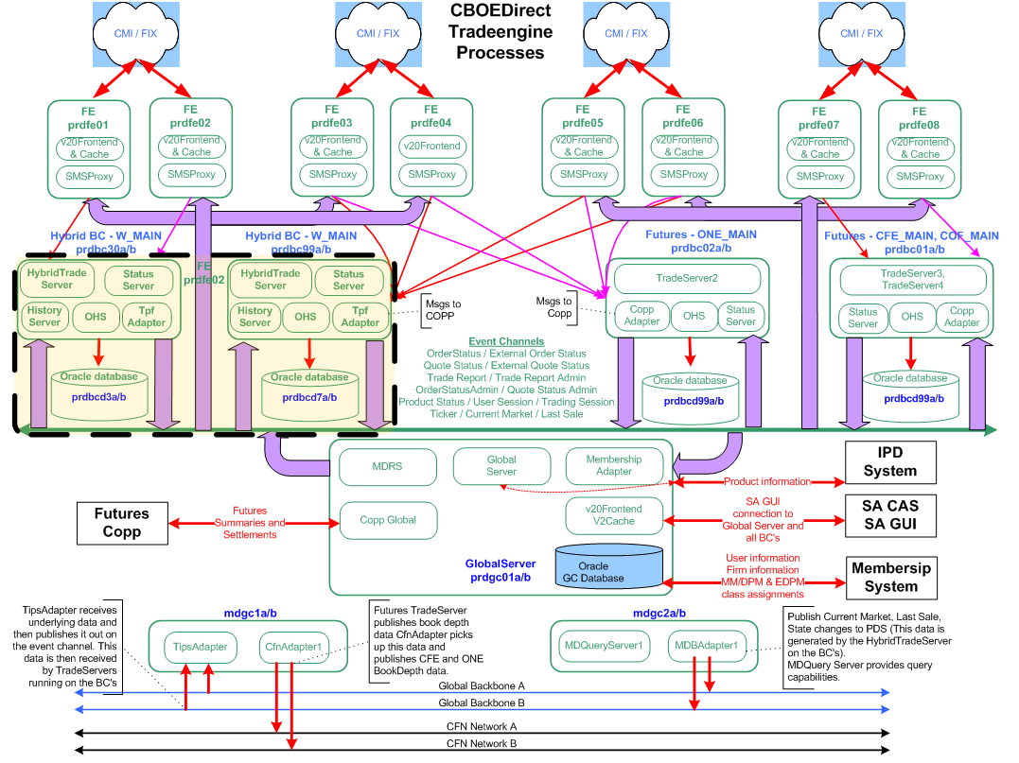

Future System Overview
Following is the future high level diagram of CBOE direct Trade engine process with the required changes:-
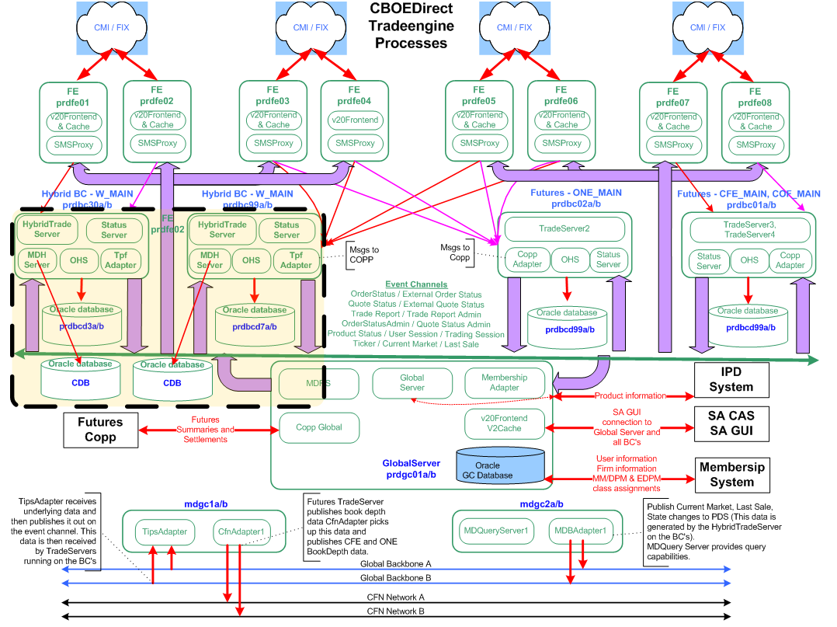

Future State
Modify CBOEdirect business cluster persistence layers to utilize an alternative, file system or write directly to the CDB for the data. This would be a phased approach to accommodate the high volume data sets first and then work on approaches for the others due to need for recoverability.
Below is the process flow diagram:

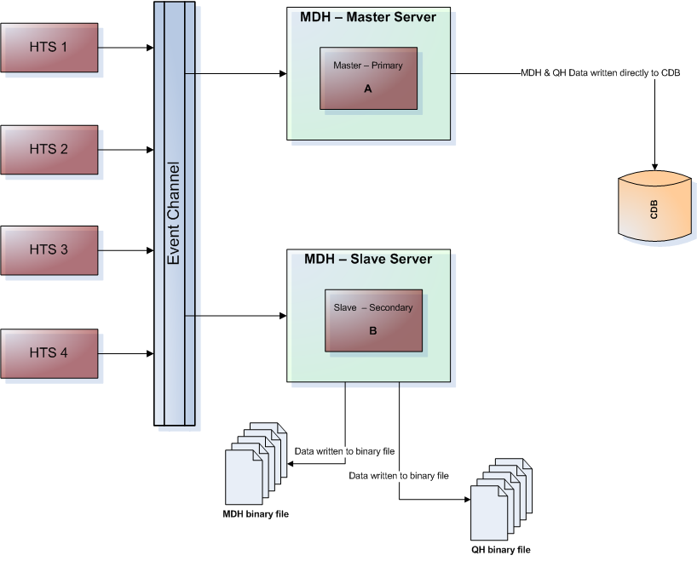

Requirement Analysis – Oracle Elimination Phase I

High-level functionalities to be implemented
Functionalities are grouped based on the system, which is most affected:-
- Configure new process for MD History Server
- MD History Server Internal Design
- Data Flow and Load Distribution (layout different options viz. Multiple BC to single MDH server or Multiple MDH server to single BC)
- CDB failure handling
  - Writing the data to a binary file
  - Import data from binary file to CDB
- Handling of MDH Querries
- MDH Server Failure
  - Detect the failure
  - Switching to the backup process
- Data Gap Detection & Handling
- Rollout Plan
- CDB Table layout for QH & MDH
- MD Buffer to CDB mapping for MDH & QH
- HHS to CDB mapping for MDH & QH
- CDB databases layout

Feasibility studies of various functionalities

Configure New Process: MD History Server
Existing Hybrid History server writes all market data to databases directly using database assign to the BC. Below requirement is used to eliminate the database on BC layer.
- Switch off existing logic/connection of history server to database.
- Create new process Market Data History Server, called ‘MDH Server’ which will write MDH and QH data directly to CDB.
- Input to MDH Server is from the event channel where data is published by BC.
- MDH Server processes the consumed data from event channel and writes it to CDB tables. See the Data Mapping in Appendix B & Appendix C sections.
- MDH Server should be configurable to intake MDH & QH data from the event channel and ensure to write correctly to CDB.
- MDH server would be running in pair, one will be master and other will be in slave mode. Two separate AMQ brokers i.e. redundant AMQ brokers would be required for master and slave MDH servers.
Slave MDH server will listen to Master MDH server using Life Line service. Life line service will be used to detect the master server failure. Master server will write directly to the CDB and slave server would continue writing to binary file during the entire business hours. Slave server will continue rolling the binary files after configurable time duration. File will have timestamp in the name and after specified size it will roll to new file name and old files will be saved in the same the same disc for the whole day. At end of the day, after reconciling all data to CDB, these binary files will be archived.
NOTE: The design of slave and master MDH server should be easily configurable to create third or more slave server without much effort and complexity.

MD History Server – Internal Design
Following are the internal design of MDH Process:
  - Filter by Class: The data needs to be filtered based on the classes assigned to the different groups. The system needs to process the data only for those classes which are assigned to the group. The system will reject / ignore all the data of other classes which are not assigned to the group.
To get rid of additional Product routing configuration arising due to multiple servers it is suggested to manage it within MDHS as detailed below:
- The MDHS would have configurable parameters: number of peers, an identity number and multiple routeNames (ex. HTS1, HTS2 … HTSn)
- The peers define how many other MDHS servers are running for this cluster while the identify number specifies what is its individual number in the list (starting 0, 1, … n)
- Whenever The MDHS<identityNumber> would listen to all the classes for the specified routeNames and with classKeys%peers=identifyNumber
- The MDHS subscribes for data to all the list of routeNames and filters according to the scheme mentioned in point 3 above
- The slave MDHS is supposed to have an exact copy of the above mentioned configuration parameters to end up subscribing to the same list of classes

Following diagram depicts the process of filter by class:
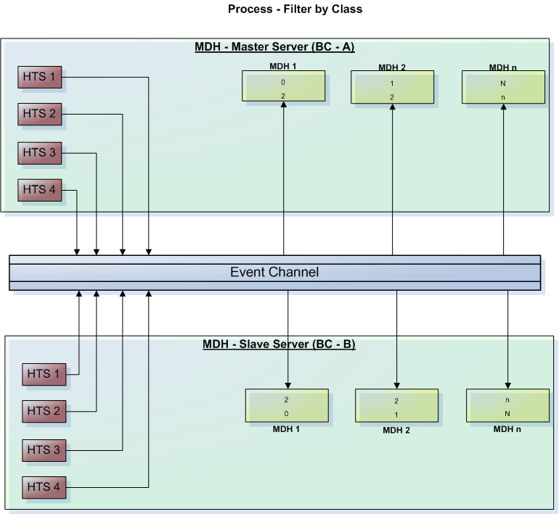
  - Create Drain File: In case, the process of data writing to CDB is slow due to various reasons, the system will drain excess data and will dump it to the two separate ‘Drain binary MDH & QH binary files’. This slowness is assumed due to other various reason including Queues to be full. Further the QH & MDH data from the Drain binary files will be written directly to the CDB by uploader component directly to CDB. There would be two separate queues (MDH & QH) created in the MDH server for the drain data while uploading to CDB from the drain file. This will be done in parallel to regular data written by master MDH server to CDB. The drain file will be created in order to reduce load of MDH server so that it can function efficiently.
Note:
Throttling: The speed of writing QH and MDH data of drain file data to CDB should be configurable. This will enable to control the data writing hence optimize the MDH process efficiently.
  - Above processes should be configurable, so we might assign multiple BCs/HTS data to one MDH process or vice versa.

Below diagram depicts the internal design of MDH server:
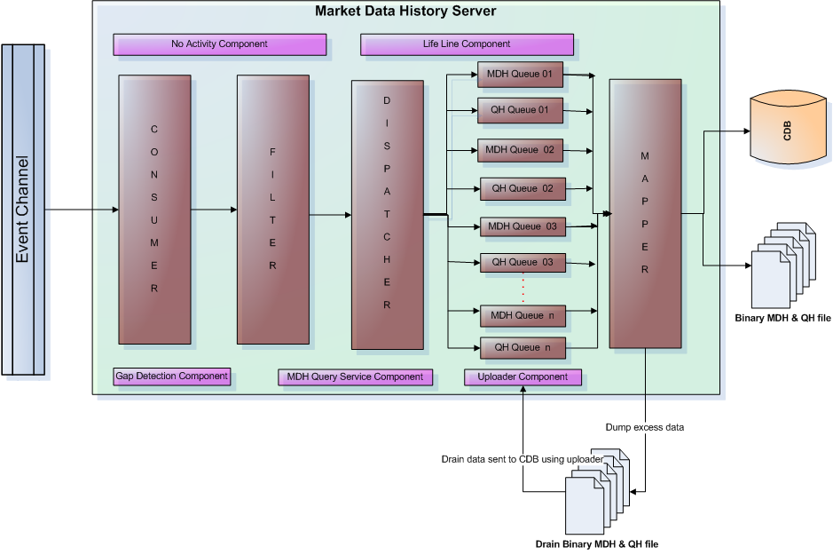
Data published by BC are available on the event channel, MDH server will consume the data for specified classes mentioned in MDH Group from the event channel. Further it processes the data using different services running within the MDH Server viz. Consumer, Filter, Dispatcher, Queue processor & Mapper. Processed data would be written to CDB.
  - Consumer: This will be at the receiver end of the event channel, which will consume the data for assign classes and passing it to next service for further processing.
  - Filter: Data of each products of the class will be filtered out by classes and pass on the filtered data to the dispatcher.
  - Dispatcher: The dispatcher will collect all the data for classes and en-queue it to the respective queues. No of queues will be created to hold the data before writing it to CDB. This should be configurable.
  - Queue processor: Queue processor will en-queue and de-queue data. De-queue data which is received from dispatcher will be passed to the mapper. There would separate queue made for MDH and QH data.
  - Mapper: The mapper will be processing the received dequeued data along with the additional data from xml. Some data like cluster id, sub cluster id won’t come with data, and we need to get it from other sources like XML. Map the data on the basis of BC and classes and write it down to CDB database.
In case, the process of data writing to CDB is slow, the mapper will dump excess data to the two separate ‘Drain binary MDH & QH binary file’. Further the QH & MDH data from the ‘Drain binary files will be written by ‘Uploader Component’ directly to the CDB in parallel to MDH server data being written directly to CDB.
For more details please refer to Use Case section 3.3.13.1
JGrinder needs to provide the facility to connect to at least four (04) data base instances.
Components brief:
- No Activity Component will be monitoring the process of data flow from Event Channel to the MDH server during the business hours. It will ensure that data is sent seamlessly by event channel to the MDH servers during the business hours.
- Life Line Component will be monitoring the MDH Master server by MDH Slave server. Please refer section Appendix: E for more detail about life line service.
- Gap Detection Component will be performing the data gap detection between event channel and MDH servers.
- MDH Query Service Component will be retrieving the requested data from CDB and pass it to MDH.
- Uploader Component: will be writing MDH & QH data from the MDH servers and MDH & QH binary files, MDH & QH drain files. For more detail please refer to section 3.3.13.2

Data Flow and Load Distribution (Different Options)
There is requirement of seamless MD & QH data flow from MDH server to CDB in a way so that the data can be stored and used in most efficient way. Based on the current discussions there are two approaches for data flow and load distribution. The two different approaches for the data flow are ‘Single BC to Multiple MDH’ and ‘Multiple BC to Single MDH’. The approach would be finalized later on and the document would be updated accordingly.
Following diagrams depict the process of data flow for these two different approaches:
- Single BC to Multiple MDH
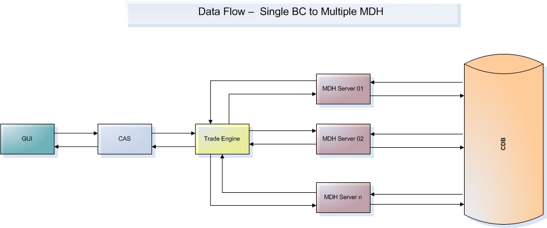

- Multiple BC to Single MDH
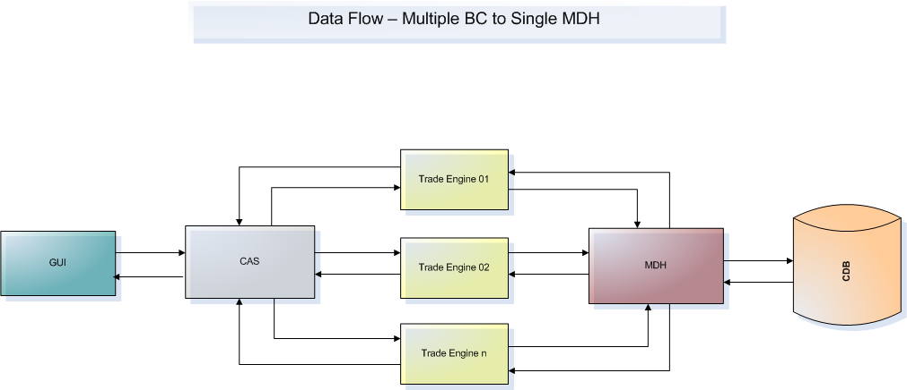

CDB Failure Handling
In case of CDB failure following process needs to be followed in MDH server process:
- Critical alarm will be issued to the Operation team apprising about CDB failure.
- In case of CDB failure, Master MDH Server would start writing two separate binary files for MDH and QH data as soon as it recognizes its failure (database being connection down). Database connection exception will be thrown when listener is down. These binary files would be saved by the MDH server with the time stamp. Whenever it starts writing to file, it will have a new file name.
- When the CDB is restored, manual command is sent to the MDH server to reconnect with CDB (ar command will be issued on MDH Server to reconnect CDB). On receiving the manual command, the master MDH server would stop writing data to the binary files and restart writing data directly to the CDB. Make sure no data is lost.
- The ‘Uploader Component’ will upload the data from the drain file and continue to upload data from the binary file created when the connection to CDB was lost. Once the data is uploaded to the CDB, system should save the file with updated name as ‘Uploaded’.
For more details please refer to Use case section 3.3.13.3

Following diagram depicts the process flow when CDB, Master MDH server and Slave MDH server is up and running:
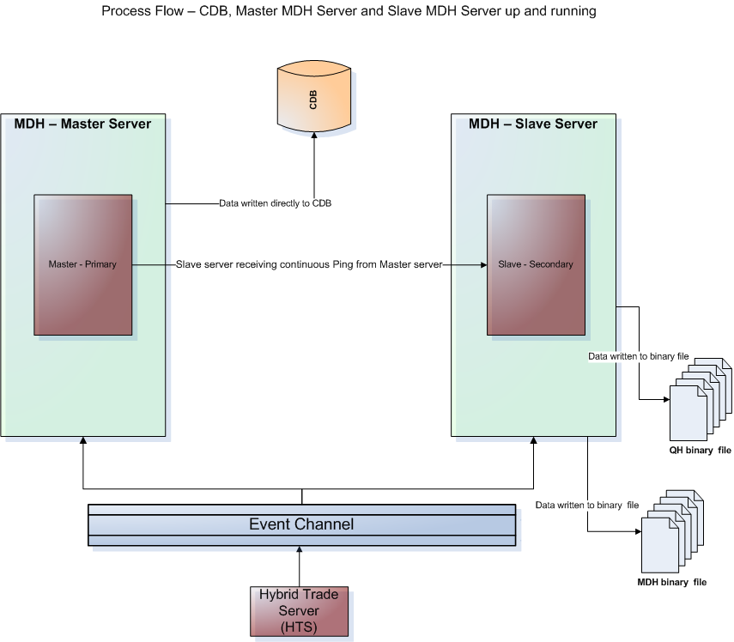

Following diagram depicts the process flow when CDB is down and Master MDH server & Slave MDH server is up and running:

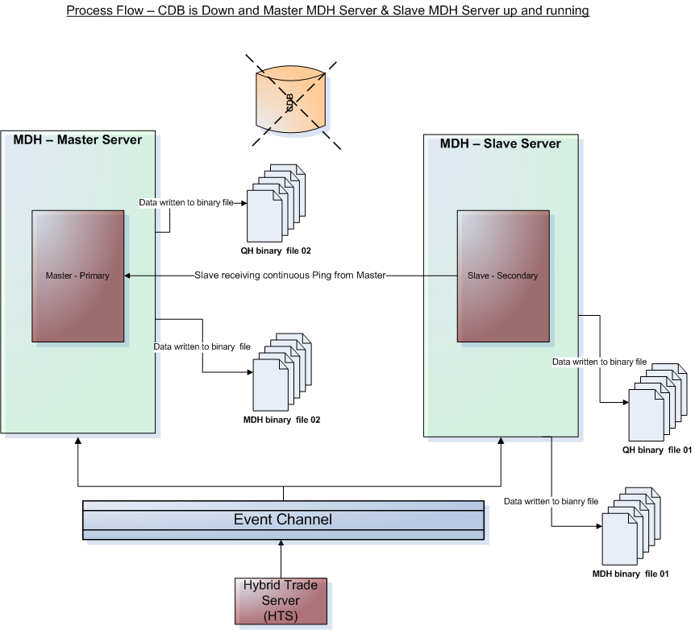

Handling of MDH Queries
The data queries should be handled by the MDH server. The MDH query service component will be performing this task. The query request would be initiated from the GUI and passed on to the MDH server via CAS and Trade engines. Further the query request would be sent to the CDB from the MDH server. The CDB would be retrieve the required data and pass it to MDH. This is similar to how HHS currently handles the query.
In case when the CDB is down, the flag will be set not to accept the MDH queries. The MDH queries would be rejected when the CDB is down.

Following diagram depicts the data flow of the MDH query:

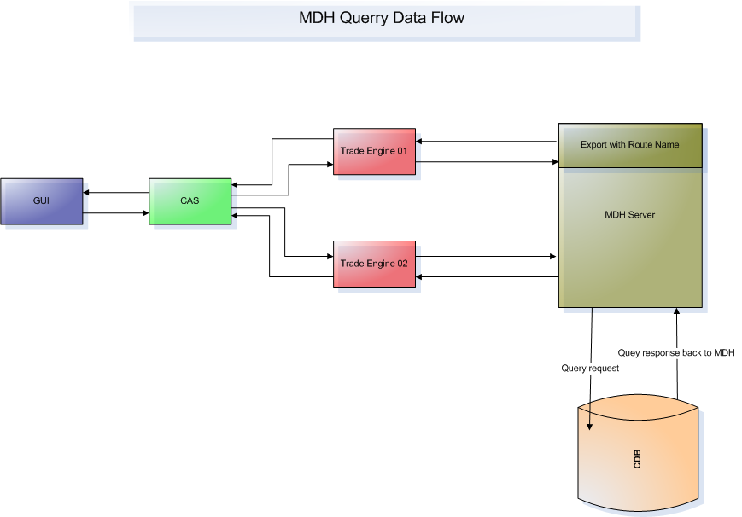

MDH Server Failure Handling
As stated above, there would be two MDH server working in parallel as master and slave. The master server would be writing the QH and MDH data directly to the CDB and slave will be writing to the binary file. Slave process will be monitoring the master process by Life line component. Please refer section Appendix: E for more detail about life line service.
In case of MDH server failure following process needs to be followed:

Detect Failure
- The life line service notifies the slave server when the master server is down. If the slave MDH server does not receive ping for more than a specified configurable time from master MDH server, then master server will be assumed to be in failed status. In such case, the slave server will first kill the master server using rsh remote facility before start working as master server.
- Critical alarm would be sent automatically to the Operation team regarding master MDH server being down.
- In case, when master server is down, the slave will become master server. In this case, the slave server will first kill the master server using rsh remote facility before start writing QH & MDH data directly to the CDB.
- The slave MDH server while working as master server will stop writing data to the binary file.
- To ensure, there is no loss of data on CDB due to master server failure, ‘Uploader Component’ will be used to upload the data from the binary file to the CDB. This will be done by MDH server, when it receives the ar command, it will start writing to CDB as well as it will invoke the ‘Uploader Component’ and load the data from MDH & QH binary files. The ‘Uploader Component’ will upload all the data saved on the binary file which is saved during the time period when MDH serer was down. Once the data is uploaded to the CDB, system should save the file with updated name as ‘Uploaded’.
- To ensure, there is no duplicate data on CDB due to file upload, it will be dependent on the constrains of CDB.
For more details please refer to Use case section 3.3.13.4
Following diagram depicts the process flow when Master MDH server is down and CDB & Slave MDH server is up and running:
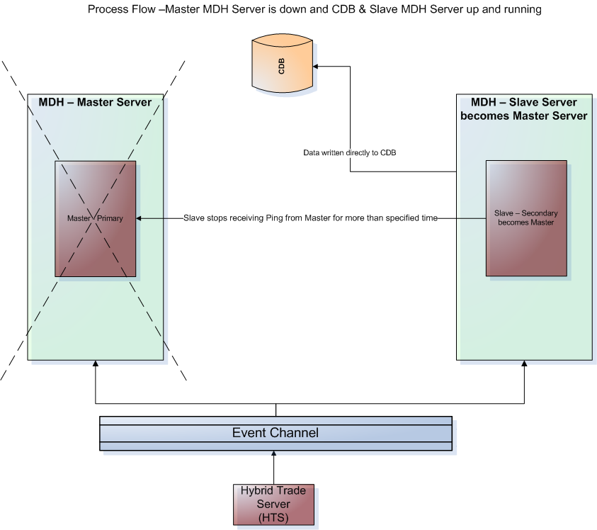

Switching to the back up process
- The master server when restored will start doing its predefined functions including writing the QH and MDH data directly to the CDB.
- When the master server is restored, the slave server (working as master server earlier) will start writing the data to the QH & MDH binary files as its predefined role.
- The slave MDH server should be receiving continuous ping from the master MDH server to ensure that the master MDH server is up and running.

Both Master and Slave MDH server down
Following steps needs to be followed when both the master and slave MDH server are down at the same time:
- Critical alarm would be sent automatically to the Operation team regarding master & slave MDH server being down.
- To ensure, there is no loss of data on CDB due to master & slave server failure, it has to be manually checked and the required data needs to be uploaded manually from the QH &MDH binary files to CDB.
- To ensure, there is no duplicate data on CDB due to manual upload, it will be dependent on the constrains of CDB.
- The master & slave server when restored will start performing its predefined role.

Network Failure Handling
There is likely scenario when there is a network failure. The network failure may happen between CDB and MDH Master server or MDH master server and MDH slave server. Following process is required to be followed in such cases:

Network failure between CDB and MDH Master Server
The network between CDB and MDH server may be disrupted when the database connection is down. In such case, following process needs to be followed:
- Critical alarm would be sent automatically to the operation team regarding network failure between CDB and MDH server.
- MDH master server would start writing the data to the two separate binary files i.e. QH and MDH binary files.
- As soon the network is restored, a manual admin request is sent to the master MDH server to try reconnecting and start writing to the CDB. This automatically stops the MDH-Master Server writing to the binary file.
- To ensure minimal loss of data the MDH-Master server would replay the latest binary file to the CDB ‘Uploader Component’. This is done as soon as it reconnects to the CDB after receiving the admin request. The remaining missing data if any would be required to be uploaded manually. Once all the lost data is uploaded to the CDB, system should save the file with updated name as ‘Uploaded’.
- Note: On reconnection after accepting the admin request only one latest file is replayed by the MDH-Master Server. The rest needs to be uploaded manually.

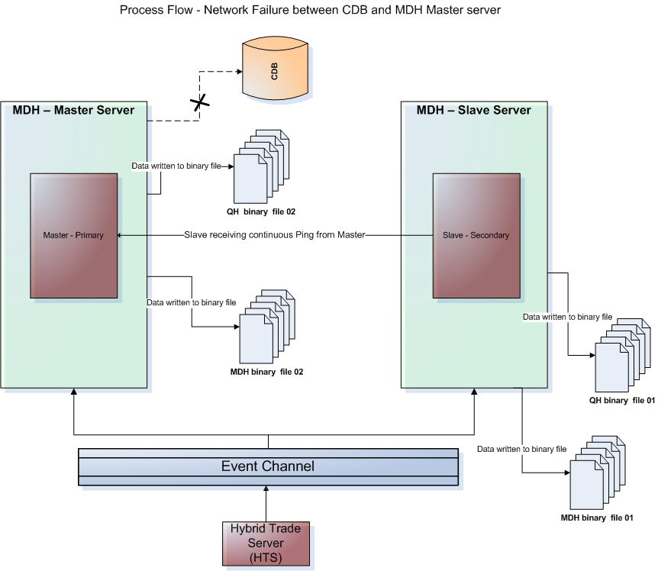

Network failure between MDH Master Server and MDH Slave Server
There is likely a scenario when the MDH slave server does not receive ping response from MDH master server due to network failure between the two hosts.
Following process needs to be followed in such cases:
- Critical alarm would be sent automatically to the Operation team regarding network between master MDH servers being down.
- Critical alarm would be sent automatically to the Operation team regarding MDH slave server not able to kill the MDH Master process which is an important step before switching to master.
Note: If the MDH-Master host is accessible and the MDH-Slave is able to terminate the non-responding process we conclude it is NOT a network failure and the steps followed are as in case 3.2.6.1
- The operation team should first ensure there is no network problem between MDH master server and CDB. We might have encountered the MDH-Master host failure or is isolated from the network.
- In such a case, of MDH-Master server host failure or being isolated from the network the following steps are required in sequence to be done manually
  - Kill the MDH-Master Server process.
  - Issue admin request command to make the MDH-Slave process to go Master.
  - Issue admin request to the MDH-Slave to connect to the CDB.
  - The new MDH-Master server will try reconnecting and start writing to the CDB. This automatically stops it from writing to the binary file.
  - To ensure minimal loss of data the MDH-Master server would replay the latest binary file to the CDB automatically using the ‘Uploader Component’. This is done as soon as it reconnects to the CDB after receiving the admin request. The remaining missing data if any would be required to be uploaded manually. Once all the lost data is uploaded to the CDB, system should save the file with updated name as ‘Uploaded’.
  - Note: On reconnection after accepting the admin request only one latest file is replayed by the MDH-Master Server. The rest needs to be uploaded manually.
- If it is not the case as discussed in iii, iv above, the operation team will manually check the network problem between MDH master server and MDH slave server and try to fix it.
- In case, the network problem between master and slave server is fixed, both the master and slave MDH server will continue working in predefined role.

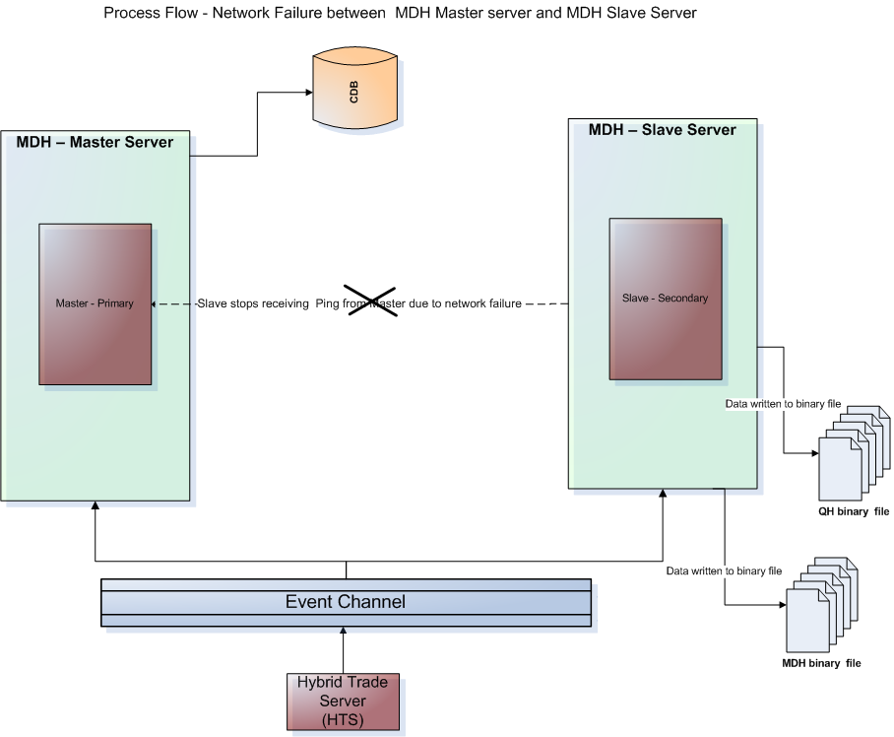

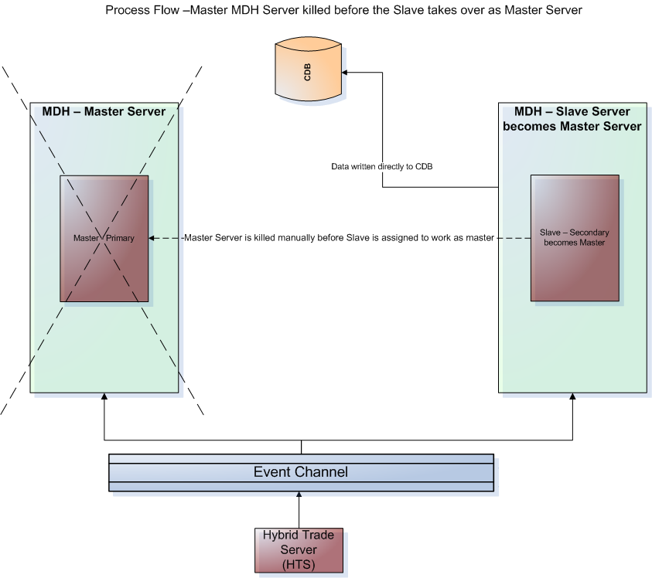

No Activity Detection / Network failure between Event Channel and MDH servers
There is likely scenario when there is a network failure between event channel and MDH servers (Master and Slave). In such case, the Master and Slave MDH servers will not receive data from the event channel due to other reasons, including network failure. ‘No Activity’ detection component will do the job of ‘Inactivity’ / Network Failure during entire business hours. In such case, when the MDH server does not receive data from Event Channel for a configurable time period, the system should send a critical alarm to the Operation team apprising about the related network failure. Further the operation team needs to take necessary action to fix the problem.
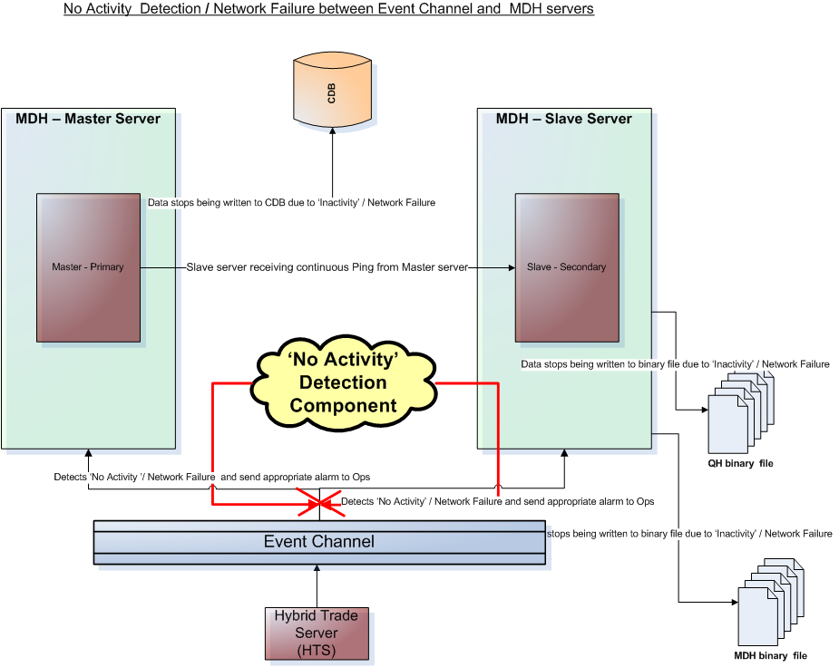

Data Gap Detection and Handling
The system should be able to perform the data gap detection activity (by gap detection component) between the Event channel and the MDH Master & Slave servers. For this purpose, publishing side i.e. HTS will additionally provide the sequence number with each data published by it to the Event Channel. There would be separate log file created when ever the gap is detected. Data gap detection will help in making sure that all data from event channel is received and processed by the MDH server as required. ‘Gap Detection Component’ will be performing this task to detect the missing data (with missing sequence number) and further will send alarm accordingly to the operation team. Whenever there is any data gap found, it will send a critical alarm along with the missing Sequence Number to operation team. Further operation team needs to map the missing data (using missing sequence number) into the database manually as required. This feature should be developed dynamically in such a manner so that Operation team can map the missing data during the day or by end of the day.
Following diagram depicts the flow of data gap detection:
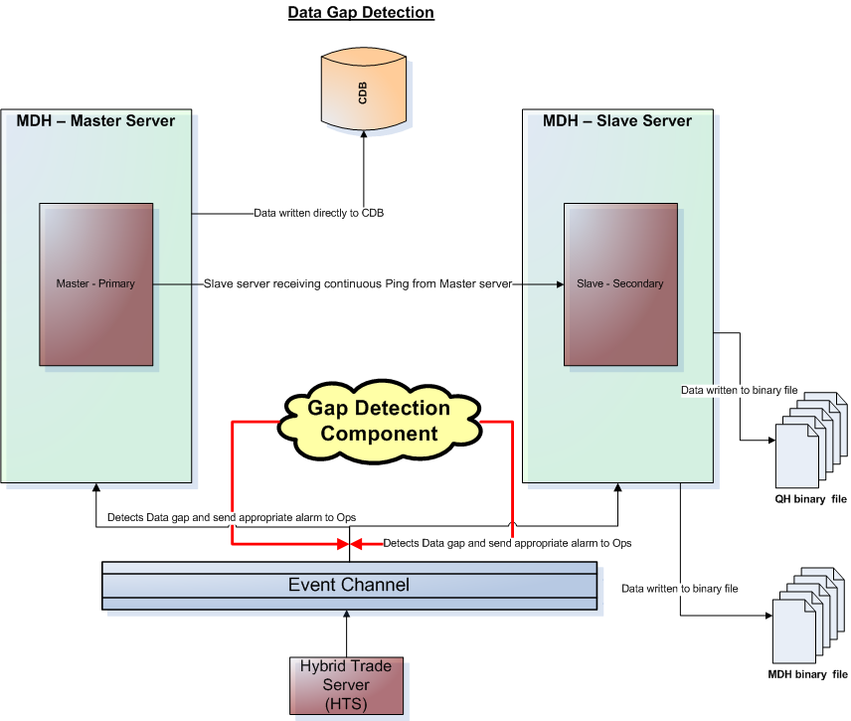

Use Case

MDH Server process

Data Flow from HTS to CDB via MDH

Business Case / Overview
This includes the MDH and QH data flow from HTS to CDB via MDH Servers.

System View and Requirements (Use Case)
Following block diagram depicts the flow
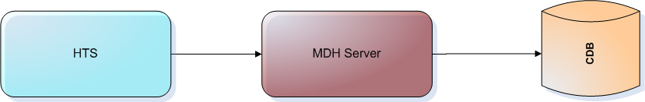

Basic Flow:
Step 1: The Market Data History and Quote History data is sent from HTS to Event Channel with sequence number.
Step 2: Event channel transmits the MDH and QH data to the MDH Server.
Step 3: Master MDH Server receives & process MDH and QH data and further writes data directly to the CDB.
Step 4: Slave MDH Server receives & process MDH and QH data and further writes data to two separate binary files i.e. MDH binary file and QH binary file.
Alternate Flows:
- System should have functionality to do the data gap detection between Event Channel and MDH Server using sequence number.
- System should have functionality to do the ‘No Activity’ detection between Event Channel and MDH Server using sequence number.
- System should have functionality to have continuous ping between MDH Master and Slave server.
- System should have functionality to dump access data to the drain file.

Uploader Component

Data Flow for Uploader Component

Business Case / Overview
This includes the MDH and QH data upload from Master MDH server. The uploader component will also the uploading data from Drain File and MDH & QH binary files to the CDB.

System View and Requirements (Use Case)
Following block diagram depicts the flow
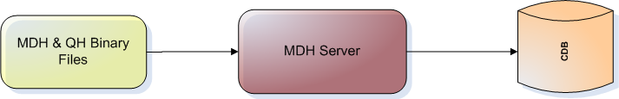

Basic Flow:
Step 1: The MDH & QH received and processed from MDH server is uploaded by uploader component to the CDB.
Step 2: As described earlier the excess data of MDH is put in the two separate drain MDH & QH files. The uploader component will be uploading the data to CDB from the drain files. There would be separate queue for the drain data.
Step 3: The uploader component will be uploading the data from other binary files to the CDB in case of CDB / MDH / network failover scenarios.
Step 4: Slave MDH Server receives & process MDH and QH data and further writes data to two separate binary files i.e. MDH binary file and QH binary file.

CDB failure

Data Flow for CDB failure

Business Case / Overview
This includes the MDH and QH data flow in case of CDB failure.

System Overview and Requirements (Use Case)
Following block diagram depicts the flow
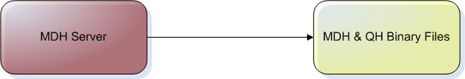
Basic Flow:
Step 1: The system will issue critical alarm to operation team and apprise about CDB failure.
Step 2: After the CDB failure detection, the Master MDH server will start writing data to the two separate MDH & QH binary files. The Slave MDH server will continue writing the data to the binary files as usual.
Step 3: The data will be written and saved in the binary files (written by master MDH server) till the CDB is restored and the Master MDH server is reconnected to CDB. The binary files would be saved with the time stamp. After the connection restoration, Master MDH server will start writing directly to CDB subsequently stop writing to the binary files.
Alternate Flow:
- The lost data during CDB failover will be uploaded from the saved binary files to the CDB using uploader component. The files will be saved with ‘Uploaded’ name after the data are uploaded.

CDB failover

CDB Instance failover

Business Case / Overview
This includes the MDH and QH data flow in case of CDB instance failover.

System Overview and Requirements (Use Case)
Following block diagram depicts the flow
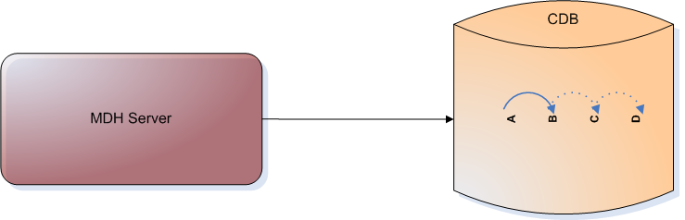
Basic Flow:
Step 1: The system will issue critical alarm about CDB instance failure.
Step 2: In this case, the JGrinder will close the connection to the current instance connected.
Step 3: After closing the connection to the current instance, MDH server will start writing data to the binary file.
Step 4: On receiving the ar command, the MDH server will start writing data directly to CDB on next backup instance. There are four such backups required.
Alternate Flow:
- The lost data during CDB instance failover will be uploaded from the saved binary files to the CDB using uploader component. The files will be saved with ‘Uploaded’ name after the data are uploaded.

CDB Host failover

Business Case / Overview
This includes the MDH and QH data flow in case of CDB host failover.

System Overview and Requirements (Use Case)
Following block diagram depicts the flow
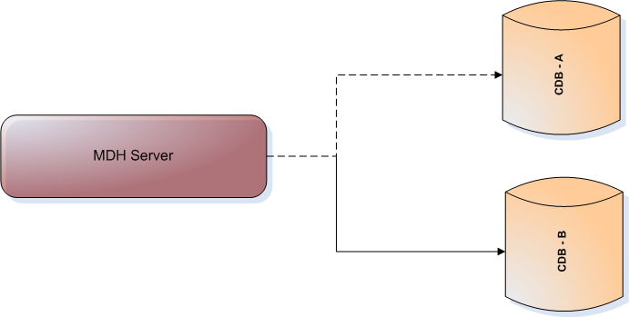
Basic Flow:
Step 1: The system will issue critical alarm about CDB host failure.
Step 2: In this case, the JGrinder will close the connection to the current CDB host connected.
Step 3: After closing the connection to the current CDB host, MDH server will start writing data to the binary file.
Step 4: On receiving the ar command, the MDH server will start writing data directly to CDB on next backup CDB host. There are four such backups required.
Alternate Flow:
- The lost data during CDB instance failover will be uploaded from the saved binary files to the CDB using uploader component. The files will be saved with ‘Uploaded’ name after the data are uploaded.

Master MDH Server Failover

Data Flow for Master MDH Server Failover

Business Case / Overview
This includes the MDH and QH data flow in case of Master MDH server failover.

System Overview and Requirements (Use Case)
Following block diagram depicts the flow
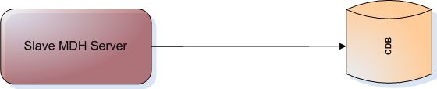
Basic Flow:
Step 1: The system will issue critical alarm to operation team and apprise about Master MDH server failure.
Step 2: The Slave MDH server will start writing data to the CDB. It will not be writing data to the binary files when writing to the CDB.
Alternate Flow:
- It has to be ensured there is no loss of data on CDB due to Master MDH server failure. For this the uploader component will upload the data from the binary files to the CDB for the time period when master MDH server was down.
- Slave MDH server would be listening to Master MDH server using Life line service. Please refer section Appendix: E for more detail about life line service.

CDB Table Layout for QH & MDH

Table Layout of MDH
Please refer to appendix A section for more detail.

Table Layout of QH
Please refer to appendix A section for more detail.

MD Buffer to CDB mapping for MDH & QH

MD Buffer to CDB mapping for MDH
MD Buffer is not available for Market Data History as of now. The document will be updated accordingly in future.

MD Buffer to CDB mapping for QH
Please refer to appendix B section for more detail.

HHS to CDB Mapping for MDH and QH

HHS to CDB mapping for MDH
Please refer to appendix C section for more detail.

HHS to CDB Mapping for QH
Please refer to appendix C section for more detail.

CDB Database Layout
Please refer to appendix D section for more detail.

Rollout Plan
There would be no special rollout procedure. It will be just another regular upgrade.

Infra To Do List
Infrastructure team is required to provide help in following tasks:
- Automatic failover between master and slave MDH sever using life line service.
- Redundant AMQ brokers for master and slave MDH server.
- JGrinder switching up to 04 backups (For CDB instance and host failover).
- Incase data base goes down infra closes only JDBC connections.

Assumptions, Constraints and Dependencies
- The duplicates data would be handled by CDB.
- CDB will be required for all the environments viz. Development, ATG, Performance, Production etc.
- There would be enough disc space available to store data for whole day by master and slave MDH server.
- MDH and QH Data on the disc will be saved by the Slave MDH server & Master MDH Server (When CDB is down or appropriate conditions) for the whole day. This disc will be emptied by EOD after data reconciliation.

Open Item and Issues
No Open Issue.

Appendix

Appendix A: CDB Table Layout for QH & MDH

Table Layout of MDH
S No. | Column Name (CDB) | Description | Data Type
 | MKT_DATA_HIST_UID | Generated primary key. Maps to DATABASEIDENTIFIER in SBT. | NUMBER(20)
 | PROD_UID | Generated primary key | NUMBER(20)
 | ENTRY_TYPE_CODE | Entry type code (1 = QUOTE, 2 = LAST SALE or PRICE REPORT, 3 = EXPECTED OPENING PRICE,4 = MARKET CONDITION)  Maps to ENTRY_TYPE in SBT. | NUMBER(2)
 | ENTRY_DATE | The time when the entry was made.  maps to ENTRY_TIME n SBT. | DATE
 | ENTRY_DATE_THOU | The time when the entry was made in thousands. | NUMBER(3)
 | BID_PRICE_IND | M=market, V=valued, N=none | CHAR(1)
 | BID_PRICE | Bid price. Maps to BID_PRICE in SBT. | NUMBER(20,8)
 | BID_SIZE | Quantity available at bid price. Maps to BID_SIZE in SBT. | NUMBER(10)
 | ASK_PRICE_IND | M=market, V=value, N=none | CHAR(1)
 | ASK_PRICE | Ask price. Maps to ASK_PRICE in SBT. | NUMBER(20,8)
 | ASK_SIZE | Quantity available at ask price. Maps to ASK_SIZE in SBT. | NUMBER(10)
 | NON_CNTG_BID_PRICE_IND | M=market, V=value,N=none | CHAR(1)
 | NON_CNTG_BID_PRICE | These values show the best quote when AON/FOK orders. Maps to NON_CONT_BID_PRICE in SBT | NUMBER(20,8)
 | NON_CNTG_BID_SIZE | These are excluded. This is the market sent to OPRA | NUMBER(10)
 | NON_CNTG_ASK_PRICE_IND | M=market, V=value,N=none | CHAR(1)
 | NON_CNTG_ASK_PRICE | Non contingency ask price | NUMBER(20,8)
 | NON_CNTG_ASK_SIZE | Non contingency ask size | NUMBER(10)
 | LAST_SALE_PRICE | Last sale price. Maps to LAST_SALE_PRICE in SBT. | NUMBER(20,8)
 | LAST_SALE_QTY | Last sale volume. Maps to LAST_SALE_VOL in SBT. | NUMBER(10)
 | UNDLY_LAST_SALE_PRICE | Price of underlying product at time entry was made. Maps to UNDLY_LAST_SALE_PRICE in SBT. | NUMBER(20,8)
 | EOP_TYPE_CODE | Expected opening price type code (OPENING_PRICE = 1; MORE_BUYERS = 2; MORE_SELLERS = 3;  NO_OPENING_TRADE = 4; MULTIPLE_OPENING_PRICES = 5; NEED_QUOTE_TO_OPEN = 6; PRICE_NOT_IN_QUOTE_RANGE= 7  NEED_DPM_QUOTE_TO_OPEN = 8  10= PRICE_NOT_IN_BOTR_RANGE  3= NEED_MORE_BUYERS  2= NEED_MORE_SELLERS  Codes 2 indicate that opening price could not be calculated because the buy or sell market orders are not fully covered. Maps to EOP_TYPE in SBT. The price will be set in the LAST_SALE_PRICE column when the EOP_TYPE_CODE = 1.  Note that Codes 2 indicate that opening price could not be calculated because the buy or sell  Market orders are not fully covered. Maps to EOP_TYPE in SBT. | NUMBER(2)
 | IMBAL_QTY | Total quantity of excess market orders. Maps to IMBALANCE_QTY in SBT. | NUMBER(10)
 | PROD_STATE_CODE | CLOSED = 1;PRE_OPEN = 2; OPENING_ROTATION = 3;OPEN = 4;  HALTED = 5;FAST_MARKET = 6;  NO_SESSION = 7;ON_HOLD = 8;  ENDING_HOLD = 9;  Maps to PRODUCT_STATE in SBT. | NUMBER(2)
 | TICK_PRFX_ACR | Condition of last sales (some text). Condition like spread, opening, out of sequence.  Maps to TICKER_PREFIX in SBT. | VARCHAR2(4)
 | SESS_NAME | Session Name | VARCHAR(30)
 | CLUSTR_CODE | Code given for a database partition. Each BCD will have one Cluster Code. | NUMBER(2)
 | BEST_PUB_BID_PRICE_IND | This column is the best public ask price INDICATOR. Y=YES, N=NO | CHAR(1)
 | BEST_PUB_BID_PRICE | This column is the best public bid price if it is better than or equal to the best public bid price at the time of trade. Otherwise it is null. Public orders include both Customer and Professional orders. Pro is defined as non-ICM/non-Customer or, alternatively, B,F,M,N,Y. | NUMBER(20,8)
 | BEST_PUB_BID_SIZE | This column is the bid size at the time when the price is equal to the best public bid price. Otherwise it is null. | NUMBER(10)
 | BEST_PUB_ASK_PRICE_IND | This column is the best public ask price INDICATOR. Y=YES, N=NO | CHAR(1)
 | BEST_PUB_ASK_PRICE | This column is the best public ask price if it is better than or equal to the best public ask price. Otherwise it is null. | NUMBER(20,8)
 | BEST_PUB_ASK_SIZE | This column is the ask size at the time when the price is equal to the best public ask price. Otherwise it is null. | CHAR(18)
 | OVRD_IND | E indicator/field. The E indicator is for expanded MDH.  Valid values are  NONE = ' '  Linkage( Last Sales items) = L  Book Override = B  Offer Override = O  Supervisory override = X.  The following 'quote' items (ENTRY_TYPE_CODE) only apply to non-Hybrid classes since there can only be one source for quotes in the Hybrid environment (and that is CBOE direct).  Codes for Market Quotes:  INDICATOR BID OFFER  Blank Manual Manual  A AutoQuote AutoQuote  B Book Book  C Manual AutoQuote  D AutoQuote Manual  E Manual Book  F Book Manual  G AutoQuote Book  H Book AutoQuote  Codes for Last Sales:  B - Trade was done at a price that the book had. The system accepted it because it was traded with the OBO or it was done on a spread.  S - Trade was reported on a supervisor terminal.  O - A trade was reported manually out of sequence by the price reporter.  (Note: When the system automatically tags a last sale entry as OSEQ, the 'E' field is left blank.) | CHAR(1)
 | NBBO_BID_PRICE_IND | NBBO Bid price Indicator. This field contains an indicator which determines whether or not this info is associated with NBBO 'Bid' information. | CHAR(1)
 | NBBO_BID_PRICE | National best bid offer - bid price. | NUMBER(20,8)
 | NBBO_BID_EXCH_VOL_TEXT | NBBO bid exchanges with volume.  The format of the nbbo_bid_exchanges field is as follows:  <Exchange symbol>:<volume>/<Exchange symbol>:<volume>/  example: ISE:200/AMEX:3000/BOX:1000  Please note that in QPE all the exchange volumes except CBOE will be set to 0. | VARCHAR2(200)
 | NBBO_ASK_PRICE_IND | NBBO ask price Indicator. This field contains an indicator which determines whether or not this info is associated with NBBO 'ASK' information. | CHAR(1)
 | NBBO_ASK_PRICE | National best bid offer - ask price | NUMBER(20,8)
 | NBBO_ASK_EXCH_VOL_TEXT | NBBO ask exchanges with volume.  The format of the nbbo_ask_exchanges field is as follows:  <Exchange symbol>:<volume>/<Exchange symbol>:<volume>/  example: ISE:200/AMEX:3000/BOX:1000  Please note that in QPE all the exchange volumes except CBOE will be set to 0. | VARCHAR2(200)
 | TRADE_THRU_IND | Trade through Indicator for last sales.  Trade Thru Indicator Trade Through: Whenever a CBOE generated last sale violates the NBBO.  Example:  NBBO is 2.10 - 2.90 and CBOE generates a last sale at 2.00.Values:Y= yesN= no | CHAR(1)
 | EXCH_IND_TEXT | Exchange name with indicatorCLEAR = 21  HALTED = 22  FAST MARKET = 23  OPENING ROTATION = 24  RESTRICTED = 25  The format of the exchanges_indicators field is as follows:  <Exchange symbol>:<indicator>/<Exchange symbol>:<indicator>/  example: ISE:21/AMEX:22/BOX:23 | VARCHAR2(200)
 | BUY_BRKR_EXCH_TEXT | Buy Broker Acronym of the broker on the buy side of trade. The broker acts as an agent for making  Securities transactions. An Account Executive or a broker at a brokerage firm deals directly with  Customers. A Floor Broker on the trading floor of an exchange actually executes someone else's  Trading orders.  Only for Entry type code = 2 - LAST SALE or PRICE REPORT | VARCHAR2(200)
 | SELL_BRKR_EXCH_TEXT | Sell Broker Acronym of the broker on the sell side of trade. The broker acts as an agent for making securities transactions. An Account Executive or a broker at a brokerage firm deals directly with  Customers. A Floor Broker on the trading floor of an exchange actually executes someone else's  Trading orders.  Only for Entry type code = 2 - LAST SALE or PRICE REPORT | VARCHAR2(200)
 | PHYS_LOC_ADDR_TEXT | This field will be used to store the manual quote information such as, location/ip address of manual quote, par id and flag to indicate whether cancel was done by user or by system.  Examples of Location field:-  AC123.456-B 123.678  A PAR1 -T 123.456  A PAR1 -  Details of Data in Physical Location  1st and 11th char => Location Indicator  2nd and 12th char => User cancel(C) or timer cancel(T)  3rd-9th and 13th -19th => PAR id or ip address  10th char => "-"  Note: Physical location field is an optional data. | VARCHAR2(20)
 | SBT_TRADE_RPT_UID | Trade ID in SBT. Maps to DATABASEIDENTIFIER in SBT and SBT_TRADE_RPT tables. | NUMBER(20)
 | BOTR_BID_PRICE_IND | Best of the Rest bid Price indicator Y=yes, N=No | CHAR(1)
 | BOTR_BID_PRICE | Best of the Rest price at which a buyer is willing to bid for a product. | NUMBER(20,8)
 | BOTR_BID_EXCH_VOL_TEXT | Best of the Rest exchange volume the buyers bid on a product/products | VARCHAR2(200)
 | BOTR_ASK_PRICE_IND | Best of the Rest ask Price indicator Y=yes, N=No | CHAR(1)
 | BOTR_ASK_PRICE | Best of the Rest ask price at which a seller is willing to sell for an exchange of a product. | NUMBER(20,8)
 | BOTR_ASK_EXCH_VOL_TEXT | Best of the Rest exchange volume the sellers ask for product/products. | VARCHAR2(200)
 | CUST_BID_BOOK_QTY | Customer asking qty entered in the book. | NUMBER(10)
 | CUST_ASK_BOOK_QTY | Customer bid qty entered in the book. | NUMBER(10)
 | CREAT_REC_TIME | The time to insert row on SBT site | TIMESTAMP(6)
 | CDB_CREAT_REC_TIME | Record created time on CDB side. Helps to identify the normal replication and missing quotes operation. | TIMESTAMP(6)
 | SUB_CLUSTR_CODE | Record created time on CDB side. Helps to identify the normal replication and missing quotes operation. | TIMESTAMP(6)

Table Layout of QH
S. No. | Column Name (CDB) | Description | Data Type
 | SBT_QUOTE_HIST_UID | Generated primary key. Maps to DATABASEIDENTIFIER in SBT. | NUMBER(20)
 | USER_ACR | Acronym of user who entered this quote (member key in the SBT quote history table).  Maps to MEMBERKEY in SBT. | VARCHAR2(10)
 | USER_ID | This is the CBOEdirect logon ID for the User who issued the QUOTE. Can be the same as USER_ACR, but need not be. The USER_ID are assigned by CBOEdirect. Maps to USERID in SBT. | VARCHAR2(15)
 | USER_UID | This is the CBOEdirect unique ID for the User who issued the Quote. | NUMBER(20)
 | USER_ASGN_ID | System assigned user id. Used only by SBT.  Maps to USERASSIGNEDID in SBT. | VARCHAR2(256)
 | PROD_UID | Generated primary key | NUMBER(20)
 | PROD_CLASS_UID | Generated primary key Maps to DATABASEIDENTIFIER in SBT. | NUMBER(20)
 | EVENT_TYPE | NEW_QUOTE = 101;  FILL_QUOTE = 102;  CANCEL_QUOTE = 103;  CANCEL_ALL_QUOTES = 104;  SYSTEM_CANCEL_QUOTE = 105;  UPDATE_QUOTE = 106;  BUST_QUOTE_FILL = 107;  Maps to EVENTTYPE in SBT. | NUMBER(3)
 | EVENT_TIME | The time this entry was created. Maps to EVENTTIME in SBT. | DATE
 | EVENT_TIME_THOU | The time this entry was created in thousands. | NUMBER(3)
 | ENTRY_STAT_IND | Status of entry (A = Active, P = marked for purging). Maps to STATE in SBT. | CHAR(1)
 | QUOTE_KEY | Sequence number assigned by quote entry system. Maps to QUOTEKEY in SBT. | NUMBER(20)
 | TRANS_SEQ_NBR | System assigned number. Used only by SBT.  Maps to TRANSACTIONSEQUENCENUMBER in SBT. | NUMBER(20)
 | BUY_SELL_CODE | Buy/sell indicator (B = Buy, S = Sell). Maps to SIDE in SBT. | CHAR(1)
 | BID_PRICE_IND | Specifies price: type M = market, type N = no price, V = valued | CHAR(1)
 | BID_PRICE | The price of the BID. Maps to BIDPRICE in SBT. | NUMBER(20,8)
 | BID_QTY | The quantity of the BID. Maps to BIDQUANTITY in SBT. | NUMBER(20)
 | ASK_PRICE_IND | Specifies price: type M = market, type N = no price, V = valued | CHAR(1)
 | ASK_PRICE | The Ask price. Maps to ASKPRICE. | NUMBER(20,8)
 | ASK_QTY | The Ask quantity. Maps to ASKQUANTITY in SBT. | NUMBER(20)
 | TRADE_PRICE_IND | Specifies price: type M = market, type N = no price, V = valued | CHAR(1)
 | TRADE_PRICE | The trade price. Maps to TRADEPRICE in SBT. | NUMBER(20,8)
 | TRADE_QTY | The trade quantity. Maps to TRADEDQUANTITY in SBT. | NUMBER(10)
 | REMN_QTY | QTY remaining after the FILL. Maps to LEAVESQUANTITY in SBT. | NUMBER(10)
 | CNCL_REAS_IND | DESIRED_CANCEL_QUANTITY = 1;  DESIRED_REMAINING_QUANTITY = 2;  CANCEL_ALL_QUANTITY = 3;  NO_USER_ACTIVITY = 23  Cancel all quotes = 12  Maps to CANCELREASON in SBT. | NUMBER(3)
 | BUST_QTY | The busted quantity. Maps to BUSTEDQUANTITY in SBT. | NUMBER(10)
 | SBT_TRADE_RPT_UID | Points to the SBT_TRADE_RPT table. Maps to TRADEDBID in SBT. | NUMBER(20)
 | UPDT_CTL_ID | This column is added for reference of fail-over persistence of the control for protection. It is added by the users to put in an arbitrary value to indicate if a quote cancellation (QRM) should be overridden. When quote cancellation is invoked, CBOEDir will check its original value and will not accept any more quotes from that user as long as they are identical. | NUMBER(5)
 | SESS_NAME | Session name. | VARCHAR2(30)
 | CLUSTR_CODE | Code given for a database partition. Each BCD will have one Cluster code. | NUMBER(2)
 | CREAT_REC_TIME | The time to insert row on SBT site | TIMESTAMP(6)
 | SUB_CLUSTR_CODE | subcluster code column  Value of subcluster will be derived based on CREAT_REC_TIME on SBT side and formula will be applied  to convert it to number.  The formula is  FLOOR ((TO_NUMBER (TO_CHAR (TO_DATE (CREAT_REC_TIME, 'SSSSS'))) / (MIN_INTERVAL15 * 60)) where  MIN_INTERVAL is 15 minute interval defined in SBT_RPLC_TAB_INF | NUMBER(4)

Appendix B: MD Buffer to CDB mapping for MDH & QH

MD Buffer to CDB mapping for QH
S. No. | Column Name (CDB) | MD Buffer  (QH) | Description | Data Type
 | SBT_QUOTE_HIST_UID | CBOE_ID | Generated primary key. Maps to DATABASEIDENTIFIER in SBT. | NUMBER(20)
 | USER_ACR | MEMBERKEY | Acronym of user who entered this quote.(member key in the SBT quote history table).  Maps to MEMBERKEY in SBT. | VARCHAR2(10)
 | USER_ID | USER_ID | This is the CBOEdirect logon ID for the User who issued the QUOTE. Can be the same as USER_ACR, but need not be. The USER_ID are assigned by CBOEdirect. Maps to USERID in SBT. | VARCHAR2(15)
 | USER_UID | USER_KEY | This is the CBOEdirect unique ID for the User who issued the Quote. | NUMBER(20)
 | USER_ASGN_ID | USER_ASSIGNED_ID | System assigned user id. Used only by SBT.  Maps to USERASSIGNEDID in SBT. | VARCHAR2(256)
 | PROD_UID | prodkey in MDMHC | Generated primary key | NUMBER(20)
 | PROD_CLASS_UID | classkey in MDMHC | Generated primary key Maps to DATABASEIDENTIFIER in SBT. | NUMBER(20)
 | EVENT_TYPE | EVENT_TYPE | NEW_QUOTE = 101;  FILL_QUOTE = 102;  CANCEL_QUOTE = 103;  CANCEL_ALL_QUOTES = 104;  SYSTEM_CANCEL_QUOTE = 105;  UPDATE_QUOTE = 106;  BUST_QUOTE_FILL = 107;  Maps to EVENTTYPE in SBT. | NUMBER(3)
 | EVENT_TIME | EVENT_TIME | The time this entry was created. Maps to EVENTTIME in SBT. | DATE
 | EVENT_TIME_THOU |  | The time this entry was created in thousands. | NUMBER(3)
 | ENTRY_STAT_IND | STATE | Status of entry (A = Active, P = marked for purging). Maps to STATE in SBT. | CHAR(1)
 | QUOTE_KEY | QUOTE_KEY | Sequence number assigned by quote entry system. Maps to QUOTEKEY in SBT. | NUMBER(20)
 | TRANS_SEQ_NBR | TX_SEQ_NUM | System assigned number. Used only by SBT.  Maps to TRANSACTIONSEQUENCENUMBER in SBT. | NUMBER(20)
 | BUY_SELL_CODE | SIDE | Buy/sell indicator (B = Buy, S = Sell). Maps to SIDE in SBT. | CHAR(1)
 | BID_PRICE_IND | BID_PRICE | Specifies price: type M = market, type N = no price, V = valued | CHAR(1)
 | BID_PRICE | BID_PRICE | The price of the BID. Maps to BIDPRICE in SBT. | NUMBER(20,8)
 | BID_QTY | BID_QTY | The quantity of the BID. Maps to BIDQUANTITY in SBT. | NUMBER(20)
 | ASK_PRICE_IND | ASK_PRICE | Specifies price: type M = market, type N = no price, V = valued | CHAR(1)
 | ASK_PRICE | ASK_PRICE | The Ask price. Maps to ASKPRICE. | NUMBER(20,8)
 | ASK_QTY | ASK_QTY | The Ask quantity. Maps to ASKQUANTITY in SBT. | NUMBER(20)
 | TRADE_PRICE_IND | TRADE_PRICE | Specifies price: type M = market, type N = no price, V = valued | CHAR(1)
 | TRADE_PRICE | TRADE_PRICE | The trade price. Maps to TRADEPRICE in SBT. | NUMBER(20,8)
 | TRADE_QTY | TRADE_QTY | The trade quantity. Maps to TRADEDQUANTITY in SBT. | NUMBER(10)
 | REMN_QTY | LEAVES_QTY | QTY remaining after the FILL. Maps to LEAVESQUANTITY in SBT. | NUMBER(10)
 | CNCL_REAS_IND | CXL_REASON | DESIRED_CANCEL_QUANTITY = 1;  DESIRED_REMAINING_QUANTITY = 2;  CANCEL_ALL_QUANTITY = 3;  NO_USER_ACTIVITY = 23  Cancel all quotes = 12  Maps to CANCELREASON in SBT. | NUMBER(3)
 | BUST_QTY | BUSTED_QTY | The busted quantity. Maps to BUSTEDQUANTITY in SBT. | NUMBER(10)
 | SBT_TRADE_RPT_UID | TRADE_DQ_ID | Points to the SBT_TRADE_RPT table. Maps to TRADEDBID in SBT. | NUMBER(20)
 | UPDT_CTL_ID | UPDATE_CONTROL_ID | This column is added for reference of fail-over persistence of the control for protection. It is added by the users to put in an arbitrary value to indicate if a quote cancellation (QRM) should be overridden. When quote cancellation is invoked, CBOEDir will check its original value and will not accept any more quotes from that user as long as they are identical. | NUMBER(5)
 | SESS_NAME | xml | Session name. | VARCHAR2(30)
 | CLUSTR_CODE | xml | Code given for a database partition. Each BCD will have one Cluster code. | NUMBER(2)
 | CREAT_REC_TIME |  | The time to insert row on SBT site | TIMESTAMP(6)
 | SUB_CLUSTR_CODE | xml  Time (Partition Wise) | subcluster code column  Value of subcluster will be derived based on CREAT_REC_TIME on SBT side and formula will be applied to convert it to number.  The formula is  FLOOR ((TO_NUMBER (TO_CHAR (TO_DATE (CREAT_REC_TIME, 'SSSSS'))) / (MIN_INTERVAL15 * 60)) where  MIN_INTERVAL is 15 minute interval defined in SBT_RPLC_TAB_INF | NUMBER(4)
 |  | REINSTATED_QTY | Note: This field is no longer in use.
 |  | TRADE_SERVER_ID | NOTE: CDB needs to map this field.

Appendix C: HHS to CDB Mapping for MDH and QH

HHS to CDB mapping for MDH
S. No. | Column Name (CDB) | Column Name (HHS) | Description | Data Type
 | MKT_DATA_HIST_UID | DATABASEIDENTIFIER | Generated primary key. Maps to DATABASEIDENTIFIER in SBT. | NUMBER(20)
 | PROD_UID | PROD_KEY | Generated primary key | NUMBER(20)
 | ENTRY_TYPE_CODE | ENTRY_TYPE | Entry type code (1 = QUOTE, 2 = LAST SALE or PRICE REPORT, 3 = EXPECTED OPENING PRICE,4 = MARKET CONDITION)  Maps to ENTRY_TYPE in SBT. | NUMBER(2)
 | ENTRY_DATE | ENTRY_TIME | The time when the entry was made.  maps to ENTRY_TIME n SBT.  Converted to oracle date and time format | DATE
 | ENTRY_DATE_THOU | MOD(ENTRY_TIME 1000) | The time when the entry was made in thousands.  milliseconds of ENTRY_TIME  The formula is:  mod(ENTRY_TIME,1000) | NUMBER(3)
 | BID_PRICE_IND | BID_PRICE | M=market, V=valued, N=none  Converted to indicator field.  The formula is:  decode(nvl(substr(BID_PRICE,1,4), ' 0'), '0', 'N', 'V' ) | CHAR(1)
 | BID_PRICE | TO_NUMBER (BID_PRICE) | Bid price. Maps to BID_PRICE in SBT.  Converted to number format  The formula is:  to_number(BID_PRICE) | NUMBER(20,8)
 | BID_SIZE | BID_SIZE | Quantity available at bid price. Maps to BID_SIZE in SBT. | NUMBER(10)
 | ASK_PRICE_IND | ASK_PRICE | M=market, V=value,N=none  Converted to indicator field  The formula is:  decode(nvl(substr(ASK_PRICE,1,4), ' 0'), '0', 'N', 'V' ) | CHAR(1)
 | ASK_PRICE | TO_NUMBER(ASK_PRICE) | Ask price. Maps to ASK_PRICE in SBT.  Converted to number format.  The formula is:  to_number(ASK_PRICE) | NUMBER(20,8)
 | ASK_SIZE | ASK_SIZE | Quantity available at ask price. Maps to ASK_SIZE in SBT. | NUMBER(10)
 | NON_CNTG_BID_PRICE_IND | NON_CONT_BID_PRICE | M=market, V=value,N=none | CHAR(1)
 | NON_CNTG_BID_PRICE | TO_NUMBER (NON_CONT_BID_PRICE) | These values show the best quote when AON/FOK orders. Maps to NON_CONT_BID_PRICE in SBT.  Converted to number format.  The formula is:  to_number(NON_CNTG_BID_PRICE) | NUMBER(20,8)
 | NON_CNTG_BID_SIZE | NON_CONT_BID_SIZE | These are excluded. This is the market sent to OPRA. | NUMBER(10)
 | NON_CNTG_ASK_PRICE_IND | NON_CONT_ASK_PRICE | M=market, V=value,N=none | CHAR(1)
 | NON_CNTG_ASK_PRICE | TO_NUMBER (NON_CONT_ASK_PRICE) | Non contingency ask price  Converted to number format  The formula is:  to_number(NON_CNTG_ASK_PRICE) | NUMBER(20,8)
 | NON_CNTG_ASK_SIZE | NON_CONT_ASK_SIZE | Non contingency ask size | NUMBER(10)
 | LAST_SALE_PRICE | LAST_SALE_PRICE | Last sale price. Maps to LAST_SALE_PRICE in SBT. | NUMBER(20,8)
 | LAST_SALE_QTY | LAST_SALE_VOL | Last sale volume. Maps to LAST_SALE_VOL in SBT. | NUMBER(10)
 | UNDLY_LAST_SALE_PRICE | NVL(UNDLY_LAST_SALE_PRICE 0) | Price of underlying product at time entry was made. Maps to UNDLY_LAST_SALE_PRICE in SBT.  Converts nulls to 0's  The formula is:  nvl(UNDLY_LAST_SALE_PRICE,0) | NUMBER(20,8)
 | EOP_TYPE_CODE | EOP_TYPE | Expected opening price type code (OPENING_PRICE = 1; MORE_BUYERS = 2; MORE_SELLERS = 3;  NO_OPENING_TRADE = 4; MULTIPLE_OPENING_PRICES = 5; NEED_QUOTE_TO_OPEN = 6; PRICE_NOT_IN_QUOTE_RANGE= 7  NEED_DPM_QUOTE_TO_OPEN = 8  10= PRICE_NOT_IN_BOTR_RANGE  3= NEED_MORE_BUYERS  2= NEED_MORE_SELLERS  Codes 2 indicate that opening price could not be calculated because the buy or sell market orders are not fully covered. Maps to EOP_TYPE in SBT. The price will be set in the LAST_SALE_PRICE column when the EOP_TYPE_CODE = 1.  Note that Codes 2 indicate that opening price could not be calculated because the buy or sell  Market orders are not fully covered. Maps to EOP_TYPE in SBT.  The formula is:  decode ( EOP_TYPE, 0, null, EOP_TYPE ) | NUMBER(2)
 | IMBAL_QTY | IMBALANCE_QTY | Total quantity of excess market orders. Maps to IMBALANCE_QTY in SBT. | NUMBER(10)
 | PROD_STATE_CODE | PRODUCT_STATE | CLOSED = 1;PRE_OPEN = 2; OPENING_ROTATION = 3;OPEN = 4;  HALTED = 5;FAST_MARKET = 6;  NO_SESSION = 7;ON_HOLD = 8;  ENDING_HOLD = 9;  Maps to PRODUCT_STATE in SBT. | NUMBER(2)
 | TICK_PRFX_ACR | TICKER_PREFIX | Condition of last sales (some text). Condition like spread, opening, out of sequence. Converts spaces to nulls.  Maps to TICKER_PREFIX in SBT.  The formula is:  decode( TICKER_PREFIX, ' ', null, TICKER_PREFIX ) | VARCHAR2(4)
 | BEST_PUB_BID_PRICE_IND | BEST_PUB_BID_PRICE | This column is the best public ask price INDICATOR. Y=YES, N=NO  Converted to indicator field.  The formula is:  decode(substr(BEST_PUB_BID_PRICE,1,4),'NONE','N' ,null,'N' ,'MKT','M','V' ) | CHAR(1)
 | BEST_PUB_BID_PRICE | BEST_PUB_BID_PRICE | This column is the best public bid price if it is better than or equal to the best public bid price at the time of trade. Otherwise it is null. Public orders include both Customer and Professional orders. Pro is defined as non-ICM/non-Customer or, alternatively, B,F,M,N,Y.  Converted to number format.  The formula is:  decode(substr(BEST_PUB_BID_PRICE,1,4),'NONE',null,'MKT',null,to_number(BEST_PUB_BID_PRICE)) | NUMBER(20,8)
 | BEST_PUB_BID_SIZE | BEST_PUB_BID_SIZE | This column is the bid size at the time when the price is equal to the best public bid price. Otherwise it is null. | NUMBER(10)
 | BEST_PUB_ASK_PRICE_IND | BEST_PUB_ASK_PRICE | This column is the best public ask price INDICATOR. Y=YES, N=NO  Converted to indicator field  The formula is:  ecode(substr(BEST_PUB_ASK_PRICE,1,4),'NONE','N' ,null,'N' ,'MKT','M','V' ) | CHAR(1)
 | BEST_PUB_ASK_PRICE | BEST_PUB_ASK_PRICE | This column is the best public ask price if it is better than or equal to the best public ask price. Otherwise it is null.  Converted to number format.  The formula is:  decode(substr(BEST_PUB_ASK_PRICE,1,4),'NONE',null,'MKT',null,to_number(BEST_PUB_ASK_PRICE)) | NUMBER(20,8)
 | BEST_PUB_ASK_SIZE | BEST_PUB_ASK_SIZE | This column is the ask size at the time when the price is equal to the best public ask price. Otherwise it is null. | CHAR(18)
 | OVRD_IND | OVERRIDE_INDICATOR | E indicator/field. The E indicator is for expanded MDH.  Valid values are  NONE = ' '  Linkage( Last Sales items) = L  Book Override = B  Offer Override = O  Supervisory override = X.  The following 'quote' items (ENTRY_TYPE_CODE) only apply to non-Hybrid classes since there can only be one source for quotes in the Hybrid environment (and that is CBOE direct).  Codes for Market Quotes:  INDICATOR BID OFFER  Blank Manual Manual  A AutoQuote AutoQuote  B Book Book  C Manual AutoQuote  D AutoQuote Manual  E Manual Book  F Book Manual  G AutoQuote Book  H Book AutoQuote  Codes for Last Sales:  B - Trade was done at a price that the book had. The system accepted it because it was traded with the OBO or it was done on a spread.  S - Trade was reported on a supervisor terminal.  O - A trade was reported manually out of sequence by the price reporter.  (Note: When the system automatically tags a last sale entry as OSEQ, the 'E' field is left blank.) | CHAR(1)
 | NBBO_BID_PRICE_IND | NBBO_BID_PRICE | NBBO Bid price Indicator. This field contains an indicator which determines whether or not this info is associated with NBBO 'Bid' information. | CHAR(1)
 | NBBO_BID_PRICE | NBBO_BID_PRICE | National best bid offer - bid price  Converted to number format.  The formula is:  decode(substr(NBBO_BID_PRICE,1,4),'NONE',null,null,null,to_number(NBBO_BID_PRICE)) | NUMBER(20,8)
 | NBBO_BID_EXCH_VOL_TEXT | NBBO_BID_EXCHANGES | NBBO bid exchanges with volume.  The format of the nbbo_bid_exchanges field is as follows:  <Exchange symbol>:<volume>/<Exchange symbol>:<volume>/  example: ISE:200/AMEX:3000/BOX:1000  Please note that in QPE all the exchange volumes except CBOE will be set to 0. | VARCHAR2(200)
 | NBBO_ASK_PRICE_IND | NBBO_ASK_PRICE | NBBO ask price Indicator. This field contains an indicator which determines whether or not this info is associated with NBBO 'ASK' information. | CHAR(1)
 | NBBO_ASK_PRICE | NBBO_ASK_PRICE | National best bid offer - ask price  Converted to number format.  The formula is:  decode(substr(NBBO_ASK_PRICE,1,4),'NONE',null,null,null,to_number(NBBO_ASK_PRICE)) | NUMBER(20,8)
 | NBBO_ASK_EXCH_VOL_TEXT | NBBO_ASK_EXCHANGES | NBBO ask exchanges with volume.  The format of the nbbo_ask_exchanges field is as follows:  <Exchange symbol>:<volume>/<Exchange symbol>:<volume>/  example: ISE:200/AMEX:3000/BOX:1000  Please note that in QPE all the exchange volumes except CBOE will be set to 0. | VARCHAR2(200)
 | TRADE_THRU_IND | TRADE_THROUGH_INDICATOR | Trade through Indicator for last sales.  Trade Thru Indicator Trade Through: Whenever a CBOE generated last sale violates the NBBO.  Example:  NBBO is 2.10 - 2.90 and CBOE generates a last sale at 2.00.Values:Y= yesN= no | CHAR(1)
 | EXCH_IND_TEXT | EXCHANGES_INDICATORS | Exchange name with indicatorCLEAR = 21  HALTED = 22  FAST MARKET = 23  OPENING ROTATION = 24  RESTRICTED = 25  The format of the exchanges_indicators field is as follows:  <Exchange symbol>:<indicator>/<Exchange symbol>:<indicator>/  example: ISE:21/AMEX:22/BOX:23 | VARCHAR2(200)
 | BUY_BRKR_EXCH_TEXT | BROKER | Buy Broker Acronym of the broker on the buy side of trade. The broker acts as an agent for making  Securities transactions. An Account Executive or a broker at a brokerage firm deals directly with  Customers. A Floor Broker on the trading floor of an exchange actually executes someone else's  Trading orders.  Only for Entry type code = 2 - LAST SALE or PRICE REPORT | VARCHAR2(200)
 | SELL_BRKR_EXCH_TEXT | CONTRA | Sell Broker Acronym of the broker on the sell side of trade. The broker acts as an agent for making securities transactions. An Account Executive or a broker at a brokerage firm deals directly with  Customers. A Floor Broker on the trading floor of an exchange actually executes someone else's  Trading orders.  Only for Entry type code = 2 - LAST SALE or PRICE REPORT | VARCHAR2(200)
 | PHYS_LOC_ADDR_TEXT | PHYSICAL_LOCATION | This field will be used to store the manual quote information such as, location/ip address of manual quote, par id and flag to indicate whether cancel was done by user or by system.  Examples of Location field:-  AC123.456-B 123.678  A PAR1 -T 123.456  A PAR1 -  Details of Data in Physical Location  1st and 11th char => Location Indicator  2nd and 12th char => User cancel(C) or timer cancel(T)  3rd-9th and 13th -19th => PAR id or ip address  10th char => "-"  Note: Physical location field is an optional data. | VARCHAR2(20)
 | SBT_TRADE_RPT_UID | TRADE_ID | Trade ID in SBT. Maps to DATABASEIDENTIFIER in SBT and SBT_TRADE_RPT tables | NUMBER(20)
 | BOTR_BID_PRICE_IND | BOTR_BID_PRICE | Best of the Rest bid Price indicator Y=yes, N=No | CHAR(1)
 | BOTR_BID_PRICE | BOTR_BID_PRICE | Best of the Rest price at which a buyer is willing to bid for a product.  Converted to number format.  The formula is:  decode(substr(BOTR_BID_PRICE,1,4),'NONE',null,null,null,to_number(BOTR_BID_PRICE)) | NUMBER(20,8)
 | BOTR_BID_EXCH_VOL_TEXT | BOTR_BID_EXCHANGES | Best of the Rest exchange volume the buyers bid on a product/products | VARCHAR2(200)
 | BOTR_ASK_PRICE_IND | BOTR_ASK_PRICE | Best of the Rest ask Price indicator Y=yes, N=No | CHAR(1)
 | BOTR_ASK_PRICE | BOTR_ASK_PRICE | Best of the Rest ask price at which a seller is willing to sell for an exchange of a product.  Converted to number format.  The formula is:  decode(substr(BOTR_ASK_PRICE,1,4),'NONE',null,null,null,to_number(BOTR_ASK_PRICE)) | NUMBER(20,8)
 | BOTR_ASK_EXCH_VOL_TEXT | BOTR_ASK_EXCHANGES | Best of the Rest exchange volume the sellers ask for a product/products | VARCHAR2(200)
 | CUST_BID_BOOK_QTY | BEST_PUB_BID_CUST_SIZE | Customer asking qty entered in the book. | NUMBER(10)
 | CUST_ASK_BOOK_QTY | BEST_PUB_ASK_CUST_SIZE | Customer bid qty entered in the book. | NUMBER(10)
 | SESS_NAME | SESSION_NAME | Session name. | VARCHAR2(30)
 | CLUSTR_CODE | CLUSTR_CODE | Code given for a database partition. Each BCD will have one Cluster code.  derived from the SBT_SESS_CLUST_INF table | NUMBER(2)
 | CREAT_REC_TIME | CREAT_REC_TIME | The time to insert row on SBT site | TIMESTAMP(6)
 | SUB_CLUSTR_CODE | SUB_CLUSTR_CODE | Record created time on CDB side. Helps to identify the normal replication and missing quotes operation.  calculated based on CREAT_REC_TIME  The formula is:  FUNCTION get_sub_clustr_code(p_timestamp IN TIMESTAMP → CREAT_REC_TIME  ,p_subpartition_min_intvl IN NUMBER → Interval of data that CDB is trying to replicate which is 200 seconds for MKT_DATA_HIST and 100 seconds for SBT_QUOTE_HIST  )  RETURN NUMBER  IS  BEGIN  IF p_subpartition_min_intvl IS NULL THEN  RETURN 0;  ELSE  RETURN FLOOR((TO_NUMBER(TO_CHAR(p_timestamp,'SSSSS')))/(p_subpartition_min_intvl*60));  END IF;  END get_sub_clustr_code; | TIMESTAMP(6)

HHS to CDB Mapping for QH
S. No. | Column Name (CDB) | Column Name (HHS) | Description | Data Type
 | SBT_QUOTE_HIST_UID | DATABASEIDENTIFIER | Generated primary key. Maps to DATABASEIDENTIFIER in SBT. | NUMBER(20)
 | USER_ACR | MEMBERKEY | Acronym of user who entered this quote (Member key in the SBT quote history table).  Maps to MEMBERKEY in SBT. | VARCHAR2(10)
 | USER_ID | USERID | This is the CBOEdirect logon ID for the User who issued the QUOTE. Can be the same as USER_ACR, but need not be. The USER_ID are assigned by CBOEdirect. Maps to USERID in SBT. | VARCHAR2(15)
 | USER_UID | USERKEY | This is the CBOEdirect unique ID for the User who issued the Quote. | NUMBER(20)
 | USER_ASGN_ID | USERASSIGNEDID | System assigned user id. Used only by SBT.  Maps to USERASSIGNEDID in SBT. | VARCHAR2(256)
 | PROD_UID | PRODUCTKEY | Generated primary key | NUMBER(20)
 | PROD_CLASS_UID | CLASSKEY | Generated primary key Maps to DATABASEIDENTIFIER in SBT. | NUMBER(20)
 | EVENT_TYPE | EVENTTYPE | NEW_QUOTE = 101;  FILL_QUOTE = 102;  CANCEL_QUOTE = 103;  CANCEL_ALL_QUOTES = 104;  SYSTEM_CANCEL_QUOTE = 105;  UPDATE_QUOTE = 106;  BUST_QUOTE_FILL = 107;  Maps to EVENTTYPE in SBT. | NUMBER(3)
 | EVENT_TIME | EVENTTIME | Converted to oracle date and time format. The time this entry was created. Maps to EVENTTIME in SBT. | DATE
 | EVENT_TIME_THOU | MOD(EVENTTIME1000) | Milliseconds of event time. The time this entry was created in thousands.  The formula is:  mod(eventtime,1000) | NUMBER(3)
 | ENTRY_STAT_IND | STATE | Status of entry (A = Active, P = marked for purging). Maps to STATE in SBT. | CHAR(1)
 | QUOTE_KEY | QUOTEKEY | Sequence number assigned by quote entry system. Maps to QUOTEKEY in SBT. | NUMBER(20)
 | TRANS_SEQ_NBR | TRANSACTIONSEQUENCENUMBER | System assigned number. Used only by SBT.  Maps to TRANSACTIONSEQUENCENUMBER in SBT. | NUMBER(20)
 | BUY_SELL_CODE | SIDE | Buy/sell indicator (B = Buy, S = Sell). Maps to SIDE in SBT. Converted to indicator field.  The formula is:  decode ( SIDE, " ", null, "0", null, SIDE) | CHAR(1)
 | BID_PRICE_IND | BIDPRICE | Specifies price: type M = market, type N = no price, V = valued. Converted to indicator field.  The formula is:  decode(nvl(BIDPRICE,0),0,'N','V') | CHAR(1)
 | BID_PRICE | TO_NUMBER(BIDPRICE) | the price of the BID. Maps to BIDPRICE in SBT. | NUMBER(20,8)
 | BID_QTY | BIDQUANTITY | The quantity of the BID. Maps to BIDQUANTITY in SBT. | NUMBER(20)
 | ASK_PRICE_IND | ASKPRICE | Specifies price: type M = market, type N = no price, V = valued. Converted to indicator field  The formula is:  decode(nvl(ASKPRICE,0),0,'N','V') | CHAR(1)
 | ASK_PRICE | ASKPRICE | The Ask price. Maps to ASKPRICE. | NUMBER(20,8)
 | ASK_QTY | ASKQUANTITY | The Ask quantity. Maps to ASKQUANTITY in SBT. | NUMBER(20)
 | TRADE_PRICE_IND | TRADEPRICE | Specifies price: type M = market, type N = no price, V = valued. Converted to indicator field.  The formula is:  decode(nvl(TRADEPRICE,0),0,'N','V') | CHAR(1)
 | TRADE_PRICE | TRADEPRICE | The trade price. Maps to TRADEPRICE in SBT. | NUMBER(20,8)
 | TRADE_QTY | TRADEQUANTITY | The trade quantity. Maps to TRADEDQUANTITY in SBT. | NUMBER(10)
 | REMN_QTY | LEAVESQUANTITY | QTY remaining after the FILL. Maps to LEAVESQUANTITY in SBT. | NUMBER(10)
 | CNCL_REAS_IND | CANCELREASON | DESIRED_CANCEL_QUANTITY = 1;  DESIRED_REMAINING_QUANTITY = 2;  CANCEL_ALL_QUANTITY = 3;  NO_USER_ACTIVITY = 23  Cancel all quotes = 12  Maps to CANCELREASON in SBT.  Converted to indicator field.  The formula is:  decode(CANCELREASON,0,null,CANCELREASON) | NUMBER(3)
 | BUST_QTY | BUSTEDQUANTITY | The busted quantity. Maps to BUSTEDQUANTITY in SBT. | NUMBER(10)
 | SBT_TRADE_RPT_UID | TRADEDBID | Points to the SBT_TRADE_RPT table. Maps to TRADEDBID in SBT. | NUMBER(20)
 | UPDT_CTL_ID | UPDATECONTROLID | This column is added for reference of fail-over persistence of the control for protection. It is added by the users to put in an arbitrary value to indicate if a quote cancellation (QRM) should be overridden. When quote cancellation is invoked, CBOEDir will check its original value and will not accept any more quotes from that user as long as they are identical. | NUMBER(5)
 | SESS_NAME | SESSION_NAME | Session name. | VARCHAR2(30)
 | CLUSTR_CODE | CLUSTR_CODE | Derived from the SBT_SESS_CLUST_INF table. Code given for a database partition. Each BCD will have one Cluster code. | NUMBER(2)
 | CREAT_REC_TIME | CREAT_REC_TIME | The time to insert row on SBT site | TIMESTAMP(6)
 | SUB_CLUSTR_CODE | SUB_CLUSTR_CODE | subcluster code column  Value of subcluster will be derived based on CREAT_REC_TIME on SBT side and formula will be applied to convert it to number.  The formula is  FUNCTION get_sub_clustr_code(p_timestamp IN TIMESTAMP → CREAT_REC_TIME  ,p_subpartition_min_intvl IN NUMBER → Interval of data that CDB is trying to replicate which is 200 seconds for MKT_DATA_HIST and 100 seconds for SBT_QUOTE_HIST  )  RETURN NUMBER  IS  BEGIN  IF p_subpartition_min_intvl IS NULL THEN  RETURN 0;  ELSE  RETURN FLOOR((TO_NUMBER(TO_CHAR(p_timestamp,'SSSSS')))/(p_subpartition_min_intvl*60));  END IF;  END get_sub_clustr_code; | NUMBER(4)

Appendix D: CDB Layout

CDB Environment
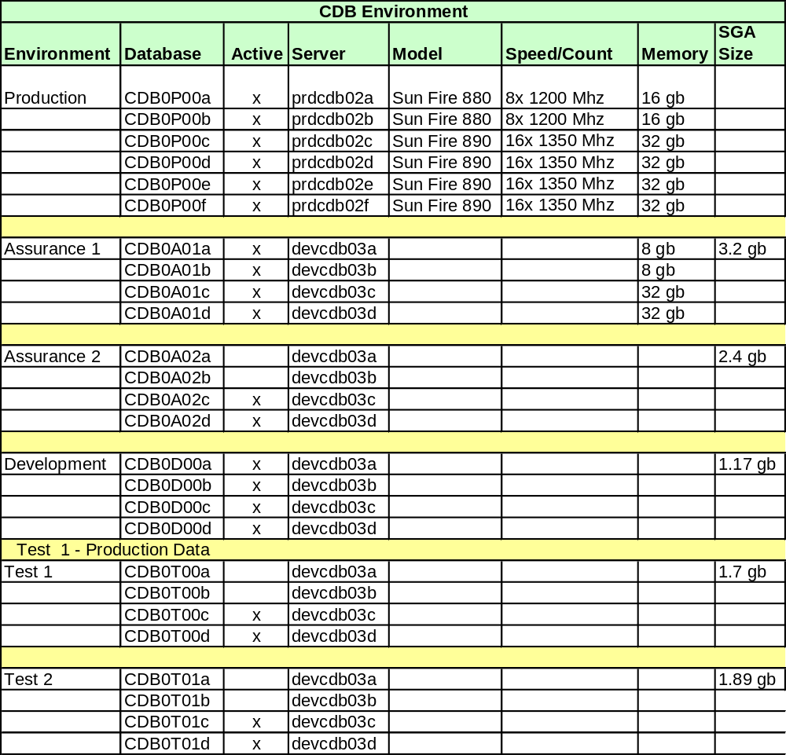

CDB Xref: CBOE direct
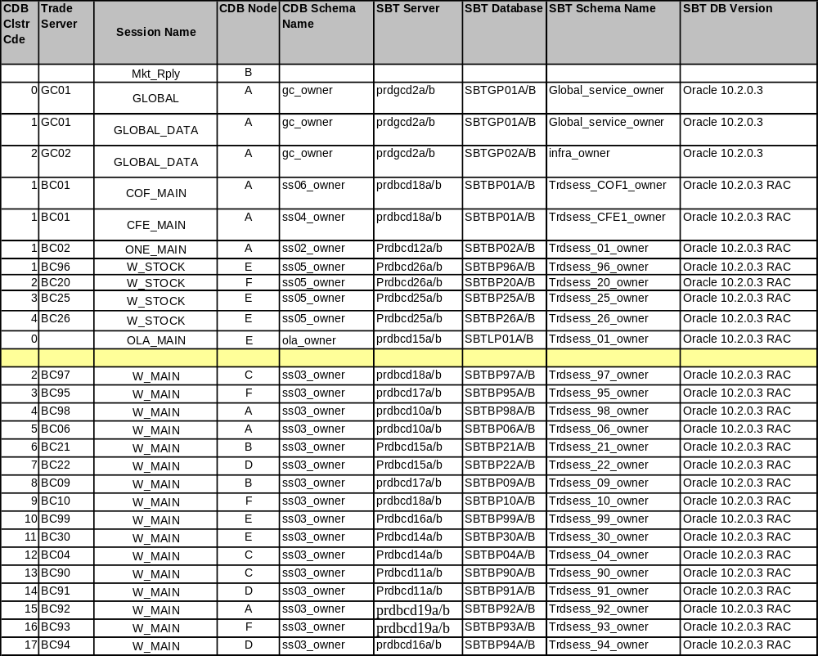

Appendix E: Life Line Service
Life Line Service's primary purpose is to provide a mechanism for a process to dynamically discover the liveness of another process, so that the former process can promptly act upon the information of the status of the later process.
Naturally, a question will be raised before using Life Line service: Should process watcher event or Life Line service be used? Of course, one process can be a listener of process watcher event for another process, and based the events to determine which action to take. But there are occasions that such indirect information is not good enough, and fast enough. Life Line service is designed for those cases where processes are closely tied, and one process's correct functioning directly depends on another process's liveness.
Life Line Service is designed as a client/server pair. The client will make lifeline call to server to determine the liveness of the server. If the lifeline call to server fails, the lifeline client will notify registered listeners the failure of lifeline server. The server is implemented by class LifeLineImpl and client is implemented by class LifeLineClientImpl.

